Interest: Simple vs Compound

Simple Interest = interest on previous principal (“deposits” or “withdrawals”) only

i_{s} = simple interest rate per interest period

End of Year (EOY) n | Flow_{n} ($) | Total Principal ($),  Princ_{n} = Sum of Flows | Interest ($),  I_{n} = i_{s} * Princ_{n-1} | Balance ($),  B_{n} = B_{n-1} + Flow_{n} + I_{n}
0

1

2

3

Substituting for I_{n}: B_{n} = B_{n-1} + Flow_{n} + i_{s} * Princ_{n-1}

Compound Interest = interest on previous balance of (principal + interest)

i = interest rate per compounding period

End of Year (EOY) n | Flow_{n} ($) | Interest ($),  I_{n} = i * B_{n-1} | Balance ($),  B_{n} = B_{n-1} + Flow_{n} + I_{n}
0

1

2

3

Substituting for I_{n}: B_{n} = B_{n-1} * (1 + i) + Flow_{n}

Compound interest is the only logically defensible type, because the source of the funds should not play a roll in whether they earn interest, so we will assume compound interest from now on.

Equivalence: Two alternatives are equivalent to the decisionmaker if the D.M. is indifferent to the choice of one over the other.

Equivalence of Cash Flows: two or more cash flows are equivalent at interest rate i iff each results in the same single amount when the flows are compounded or discounted at rate i to a common point in time.
We may want to equate flows at different times: present, future, over a range

Single Present and Future Amounts

define:
i = interest rate per compounding period
P = “present” amount at time z
F (or F_{n}) = equivalent amount at a later time, at n periods from the “present”
n=number of compounding periods between the two points in time

a) Compounding

EOP | Flow_{n} | B_{n} = B_{n-1} * (1 + i) + Flow_{n}
z+0

z+1

z+2

z+n

Find F, given P, i, n:
F = P(1 + i)^{n}

Functional notation: F = P(F/P, i, n)

where (F/P, i, n) = “the ratio of F to P at interest rate i, where F is n periods after P”

b) Discounting

Find P, given F, i, n:
P = F/(1 + i)^{n} = F(1 + i)^{-n}

Functional notation: P = F(P/F, i, n)

where (P/F, i, n) = “the ratio of P to F at interest rate i, where P is n periods before F”

Uniform (equal payment) Series

Given: equal amounts A, at the end of each period, for n periods
Find: equivalent P at beginning of the first period

-[ P = A(1+i) ⁻¹ + A(1+i) ⁻² + . . . + A(1+i) ^{-(n-1)} + A(1+i) ^{-n}]
(1 + i)P = A + A(1+i) ⁻¹ + . . . . . . . . . . . . + A(1+i) ^{-(n-1)}_________
iP = A[ 1 - (1+i) ^{-n} ]

Divide by i and multiply RHS by (1+i)^{n}/(1+i)^{n} to get:

P = A [ (1+i)^{n} - 1] this is the form in Park’s text
[ i (1+i)^{n} ]

shorthand: P = A (P/A,i,n)

what happens as n goes to infinity?

P = for an infinite series

What if want future value of the series, at time n?

can chain relationships together, as long as i and n are the same:

have (P/A, I, n), and (F/P, I, n) = (1 + i)^{n}

so can find (F/A,i,n) = (P/A,i,n)(F/P,i,n) = [ (1+i)^{n} - 1]
[ i ]

F = A(F/A,i,n)
Nominal Rate and Effective Rates

The following terminology is simpler and a bit more general than the text’s.

r = nominal interest rate per year (also called annual percentage rate or APR)
m = number of compounding periods per year
r/m = i = rate per compounding period
w = some number of compounding periods
i_{e} = effective interest rate per w compounding periods

Compounding Period | Periods/year, m
year | 1
quarter | 4
month | 12
day | 365
(continuous) | infinite

i_{e} = (amt. at end – amt. in) / amt. in = (F - P) / P = (P(1+i)^{w} - P) / P = ________________

If w = m (so the rate is for one year) then i_{e} is known as the effective annual rate or annual yield.

what if m goes to infinity?

i_{e} = (1 + r/m)^{w} - 1 = (1 + r/m)^{(m/r)r(w/m)} - 1 = e^{r(w/m)} - 1
as m goes to infinity

w = # compounding periods = years
m # comp. periods per year

i_{e} = for continuous compounding

Effective annual rates for some example values of r and m:

Comp. Period | r = 5%/yr | r = 10%/yr
year | 5.% | 10.%
month | 5.1162% | 10.4713%
day | 5.1268% | 10.5156%
(continuous) | 5.1271% | 10.5171%

Note without proof: An effective rate (i_{e}) can be used in the same relationships as a rate per compounding period (i) as long as the rate and period match

Analysis Considering Inflation

When the base year is year zero and we are trying to find P:

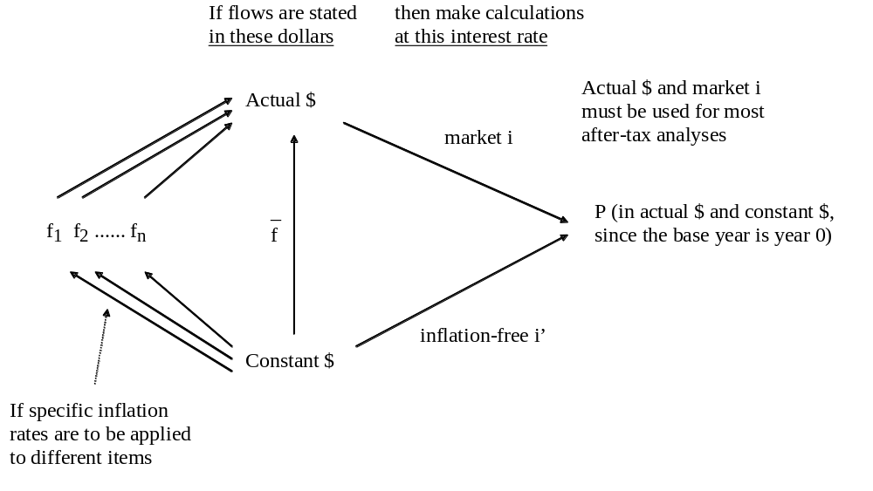

In ENG 106, unless we state otherwise, we assume that either:

a) flows are in actual $ and the interest rates are market rates (i),
or
b) there is no inflation. This simplifies examples: when f = 0 then i = i’ and Flow_{n} = Flow_{n}’.

(Unfortunately, the text is not always clear on these points. It sometimes mixes what seem to be actual-dollar flows with inflation-free interest rates or constant-dollar flows with market rates.)

Decision Criteria (rules) for Dollar-Valued Bases

Alternatives:

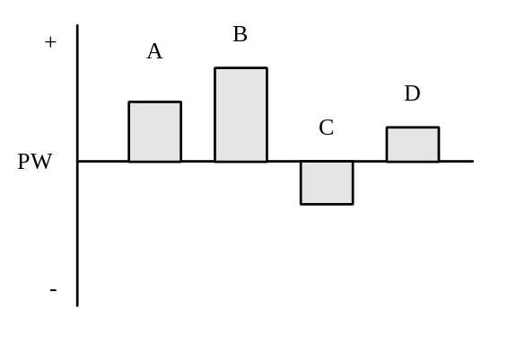
Objective: Maximize Net Present Worth

 | If Alternatives are:
$-Valued Basis | M.E. | Independent*
PW | Choose the one alt with the highest PW | Choose all alts with PW > 0
FW | Choose the one alt with the highest FW | Choose all alts with FW > 0
AEW | Choose the one alt with the highest AEW | Choose all alts with AEW > 0
notes: | only need to evaluate differences between alts; can ignore common elements | all benefits and costs for an independent project must be stated in $
* The text sometimes states, “Is the project acceptable?” This implies that the project is independent.

Benefit/Cost (B/C) Ratio
B = PWbens
C = PWcosts = PW of initial (capital) expenses + PW of later (annual operating) costs
C = I + C’
BC(i) = B/C, the benefit/cost ratio evaluated at interest rate i

A. Derive the decision rules for BC(i) so they are consistent with maximizing NPW:

1) for independent alternatives
accept an indep alt if: Net PW = B - C > 0
B > C
BC(i) = B / C > 1 for C > 0

2) for mutually exclusive alternatives
choose the alternative with maximum NPW

for now, compare only two alts, J and K:
define the incremental alternative = K - J (the difference between the two)

accept K over J if: Net PW_{K} > Net PW_{J}
B_{K} - C_{K} > B_{J} - C_{J}
B_{K} - B_{J} > C_{K} - C_{J}
Δ B_{K-J} > Δ C_{K-J}
BC(i) _{K-J} = Δ B_{K-J} / Δ C_{K-J} > 1 for Δ C_{K-J} > 0

BC(i) _{K-J} is properly called the B/C ratio on the incremental alternative, not the incremental B/C ratio.
In other words, accept the incremental alternative K-J if the B/C ratio for the increment is greater than 1.

Note that the rule is not BC_{K} > BC_{J} ; we should not compare B/C ratios for M.E. alts!!!

With M.E. alternatives, we must use an incremental approach: discard alternatives by comparing them two at a time until only the best remains.

B. Derive the decision rule for independent alternatives, using the profitability index, PI(i)

accept an indep alt if: B > C
B > I + C’
net benefit, B’ = B - C’ > I
profitability index, PI(i) = (B - C’) / I > 1 for I > 0

Decisions made with BC(i) or PI(i) are equally valid, because they are consistent. The values of the two ratios will be different, but they will be always be on the same side of the threshold decision value of one.

Similarly, you can show that both BC(i) and PI(i) are valid for incremental analysis of M.E. alternatives.

Summary of the IRR Decision Process for:
- an independent alternative’s cash flow
- or the flow for an incremental alternative (between two M.E. alternatives)

1) Be sure the first non-zero flow is negative. This guarantees an investment, so the sense of the decision rule will be correct.

Cash Flow: Simple Investment Non-Simple Investment

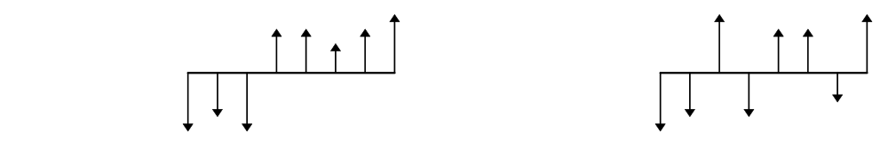

2) Set PW = 0 and find one of the i* > -100%

3) Calculate PB(i*)
(required only for non-simple flows)
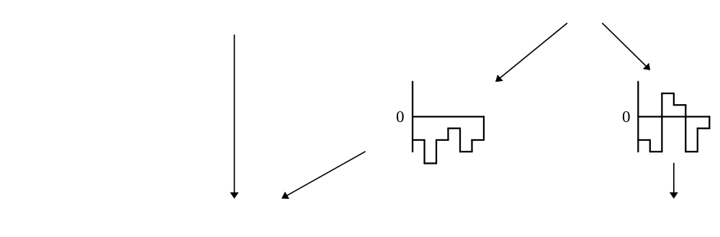

Type of Investment: Pure Mixed

only one i* > -100% there may be more than one i*,
but this doesn’t matter
because i*s are irrelevant here

IRR = i* IRR = f(MARR)

3) Set PB (IRR,MARR)_{N} = 0
to find the IRR
(or use PW basis rather than IRR)

4) Accept the alternative (or incremental alternative) if IRR > MARR

because the PW of the flow > 0 if IRR > MARR
Using IRR to evaluate Mutually Exclusive Alternatives

Example: Five M.E. alts
A, C, D & E have 3-year lives; B has a one-year life and is repeatable
There is a 3-year period of need
MARR = 15%/yr, f ~ 4.5%/yr
Net cash flows are stated in Year-Zero $

Alt Net Flows NPW@ IRR

A 100 90 80
100

B 50

C 90 110 75
100

D 70 115 65
80

E 90 90 75
150
MACRS Property Classifications

(Table 9.7 on p.380 in Park’s “Fundamentals…, 3rd Ed.”)

Example of Type of Property | Recovery Period,  years | Depreciation  Method | Depreciation  Table
Special machine tools | 3
Research & Development equip. | 5
Manufacturing equipment | 7
Railroad cars | 10
Wastewater plants | 15
Electric power plants | 20
Residential real property | 27.5
Commercial buildings | 39

Taxes and After-Tax Cash Flows
(notes related to some material in Chapters 9 and 10 in Park’s “Fundamentals…, 3rd Ed.”)

If income taxes did not exist, it would be relatively straightforward to add up the cash flows in each year. For any taxpayer, income tax is a part of the overall cash flow. A valid analysis must consider all flows associated with projects or alternatives, so the flow needed at each point in time (i.e. in each year) is the Net After-Tax Cash Flow, ATCFn. Calculating the income tax in each year is not a trivial problem because different elements of the before-tax cash flows are treated differently for tax purposes.

I. Types of Cash Flows (in year n)
Park divides flows for corporations into three categories: operating, investing and financing. It is not necessary to do this, but the division may help in visualizing the overall picture.

A. From Operating Activities
Rn: Gross Revenue or Income (or savings)
from sales of goods and services (or savings attributed to the project)
En: Operating Expenses
costs of items "used up" within the year including:
- costs of materials etc. for goods sold
- salaries and wages
- energy, advertising, property and sales taxes
- rent/lease payments
In: Interest Expenses
interest (not principal) payments on borrowed funds
Tn: Income Taxes
is a function of Taxable Income, TIn (see table on p. 387 in Park)
For an incremental project in a large company:
Tn = TIn * tm where tm is the marginal tax rate

B. From Investment Activities
Pn: Investment in Capital Assets (is a flow in the year an asset is purchased)
is the cost base for items that last for more than one year:
- non-depreciable assets (land, stocks, bonds)
- depreciable assets (buildings, equipment, etc)
Sn: Salvage Value of Capital Assets (is a flow in the year an asset is sold)
Gn: Gains Tax
tax on the excess of salvage value Sn over book value Bn (is a flow in the year sold)
Depending on the whims of Congress, gains are taxed at the ordinary income rate or at a lower rate; it can
be quite complicated. Assuming the same rate for simplicity, for large companies:
Gn = (Sn - Bn) * tm
where Book Value Bn:
= cost base, Pn, for non-depreciable assets
= Pn - the sum of depreciation for the asset through the year sold
Wn: Working Capital Investment
Amounts invested, usually near the start of a project, to:
- build an inventory of goods
- cover accounts receivable
- supply cash on hand for day-to-day needs
Wn': Working Capital Recovery or Release
Amounts of Wn recovered, usually near the end of a project

C. From Financing Activities
Bn: Borrowing (of loan principal or bond principal)
PPn: Repayment of Borrowed Principal
II. Income Tax Relationships
Only some of the cash inflows are taxed, and only some of the cash outflows may be deducted

Rn: is taxed
En, In: can be deducted
Pn: can't be deducted, is just a "swap" of money for assets of equal value
but: can deduct depreciation Dn for depreciable assets, as assets are "used up" for the business
Depreciation is not a cash flow, but it affects cash flow by its influence on income tax
Sn: is not taxed directly
but any amount above book value is taxed as a gain: Park treats gains tax, Gn, separately
Wn, Wn': no deduction or tax
Bn, PPn: no tax or deduction

One method of summarizing and calculating Net After Tax Cash Flow is called the Generalized Cash Flow Approach. This is a logical approach. In any year n:
Taxable Income, TIn = Rn - En - In - Dn
Income Tax, Tn = a function of TIn
Net After-Tax Cash Flow, ATCFn = Rn - En - In - Tn - Pn + (Sn - Gn) - Wn + Wn' + Bn - PPn

for incremental projects in a large company:
Income Tax, Tn = (Rn - En - In - Dn) * tm
substituting into ATCFn above gives:
ATCFn = (Rn - En - In) * (1 - tm) + Dn * tm - Pn + (Sn - Gn) - Wn + Wn' + Bn - PPn

This final relationship gives some insight into what changes in after-tax flows would result from changes in the various components.

Another method is called the Income Statement/Cash Flow Statement Approach because it parallels the method accountants take to find taxable income and "Net Income" = taxable income - income tax, which is used for financial reports but is not the same as Net After-Tax Cash Flow. "Net Income", as defined here, should never be used as a cash flow in economic analyses of alternatives. It is possible, however, to calculate net cash flow from net income, although the method is somewhat circuitous. I'm not sure that accountants really understand it. In this approach, Net Income is calculated, then depreciation, which is not a cash flow but was subtracted earlier to get taxable income, is added back on to get Cash Flow from Operations. Then the other flows, which had no bearing on taxable income, are added or subtracted to find the Net After-Tax Cash Flow. In any year n:
Rn
- En
- In
- Dn
= TIn, Taxable Income
- Tn, Income Tax = a function of TIn
= Net Income
+ Dn
= Cash Flow from Operations
- Pn
+ Sn
- Gn
- Wn
+Wn'
+ Bn
- PPn
= ATCFn, Net After-Tax Cash Flow

As an example, look at all the cash flows in one year n for a business:
Description | Amount | Cat | Cash Flow | Amounts considered when calculating taxes
Buy land | 1,000,000
Buy (construct) residential bldg | 3,000,000
Depreciation on bldg: put in service in September | 31,830*
*(3.5/12)(1/27.5)(3,000,000) = 31,830 Park, pp. 380, 383-384
Buy lawnmower | 4,000
Depreciation on mower  (5 yr prop) | 800**
**20%(4,000) = 800 Park, pp. 380-381
Sell other property  (land+bldg)*** | 1,000,000
Dorm contracts | 350,000
Utilities | 40,000
Labor | 60,000
Food used | 80,000
Rent BBQ | 200
Food inventory | 10,000
Loan
Borrow principal | 2,000,000
payments this year = 40k
repay principal | 10,000
interest | 30,000 |  | ___________ | ___________
Before-Tax Cash Flow |  | BTCFn
Taxable Income |  | TIn
Income Tax | 25,046# | Tn |  | ___________
# 22,250 + 0.39*(taxable income-100,000) = 25,046 Park p. 387
“Net Income”
Gain*** | 600,000
***when purchased: I = 700k
depreciation until now: ΣD = 300k
current book value: B = I - ΣD = 700 - 300 = 400k
so have a Gain = actual selling price – B = 1,000k - 400k = 600k
Gains are taxable, but are not “TI” since they may or may not be taxed at same rate as TI.
For simplicity here, we’ll assume they are taxed at the same rate as TI
Gains tax | 215,342## | Gn | ___________
## 113,900 + 0.34*(taxable income + gain - 335,000) – income tax (above) = 215,342 Park p. 387
After-Tax Cash Flow |  | ATCFn

ATCF is the “bottom line” value needed for economic evaluation, in each year n

After-Tax Analysis Table, Using Income Statement/Cash Flow Statement Approach

a) without inflation or ignoring inflation
Year: | 0 | 1 | 2 | 3
Revenue, Rn
Expenses, En
Interest Pmts, In
Depreciation, Dn | _____ | _____ | _____ | _____
Taxable Income, TIn
Taxes, Tn: TIn * tm | _____ | _____ | _____ | _____
Net Income
Depreciation, Dn | _____ | _____ | _____ | _____
Cash Flow from Oprns
Asset Purchase, Pn
Salvage, Sn
Gains Tax, Gn:
(Sn - Book Value) * tm
Working Cap. Invest., Wn
Working Cap. Recov., Wn'
Borrowing (loans), Bn
Principal Repayment, PPn | _____ | _____ | _____ | _____
A.T. Cash Flow, ATCFn

After-Tax Analysis Table, Using Income Statement/Cash Flow Statement Approach

b) considering inflation
Year: | 0 | 1 | 2 | 3
Revenue, Rn
Expenses, En
Interest Pmts, In
Depreciation, Dn | _____ | _____ | _____ | _____
Taxable Income, TIn
Taxes, Tn: TIn * tm | _____ | _____ | _____ | _____
Net Income
Depreciation, Dn | _____ | _____ | _____ | _____
Cash Flow from Oprns
Asset Purchase, Pn
Salvage, Sn
Gains Tax, Gn:
(Sn - Book Value) * tm
Working Cap. Invest., Wn
Working Cap. Recov., Wn'
Borrowing (loans), Bn
Principal Repayment, PPn | _____ | _____ | _____ | _____
A.T. Cash Flow, ATCFn

Replacement Analysis: Challenger
Assumptions |  | Cash flows, actual $
EOY | P | S - G (1) | OpsFlw (2) | Other (3)
0
1
2 |  |  |  |  |  | (1) Net salvage value (S - G) if sold at end of this year
3 |  |  |  |  |  | (2) Operations Flow in this year = (R - E - I)(1 - tm) + tm*D
4 |  |  |  |  |  | (3) Other flow in this year = -W + W' + B - PP
5
6
 | MARR, %/yr:
 | f, %/yr:
Calculations
 | MARR', %/yr:
Years Kept, N: | 1 |  | 2 |  |  | 3 |  |  |  | 4
EOY: | 0 | 1 | 0 | 1 | 2 | 0 | 1 | 2 | 3 | 0 | 1 | 2 | 3 | 4
Ops Flow, A$:
P, A$:
S-G, A$:
Other, A$:
ATCF, A$:
PW, $:
AEW, C$/yr:
Years Kept, N: | 5 |  |  |  |  |  | 6
EOY: | 0 | 1 | 2 | 3 | 4 | 5 | 0 | 1 | 2 | 3 | 4 | 5 | 6
Ops Flow, A$:
P, A$:
S-G, A$:
Other, A$:
ATCF, A$:
PW, $:
AEW, C$/yr:

Replacement Analysis: Defender
Assumptions |  | Cash flows, actual $
EOY | O.C. (0) | S - G (1) | OpsFlw (2) | Other (3)
0
1 |  |  |  |  |  | (0) Opportunity cost (S - G) if not sold now
2 |  |  |  |  |  | (1) Net salvage value (S - G) if sold at end of this year
3 |  |  |  |  |  | (2) Operations Flow in this year = (R - E - I)(1 - tm) + tm*D
4 |  |  |  |  |  | (3) Other flow in this year = -W + W' + B - PP
5
6
 | MARR, %/yr:
 | f, %/yr:
Calculations
 | MARR', %/yr:
Years Kept, N: | 1 |  | 2 |  |  | 3 |  |  |  | 4
EOY: | 0 | 1 | 0 | 1 | 2 | 0 | 1 | 2 | 3 | 0 | 1 | 2 | 3 | 4
Ops Flow, A$:
P, A$:
S-G, A$:
Other, A$:
ATCF, A$:
PW, $:
AEW, C$/yr:
Years Kept, N: | 5 |  |  |  |  |  | 6
EOY: | 0 | 1 | 2 | 3 | 4 | 5 | 0 | 1 | 2 | 3 | 4 | 5 | 6
Ops Flow, A$:
P, A$:
S-G, A$:
Other, A$:
ATCF, A$:
PW, $:
AEW, C$/yr:

